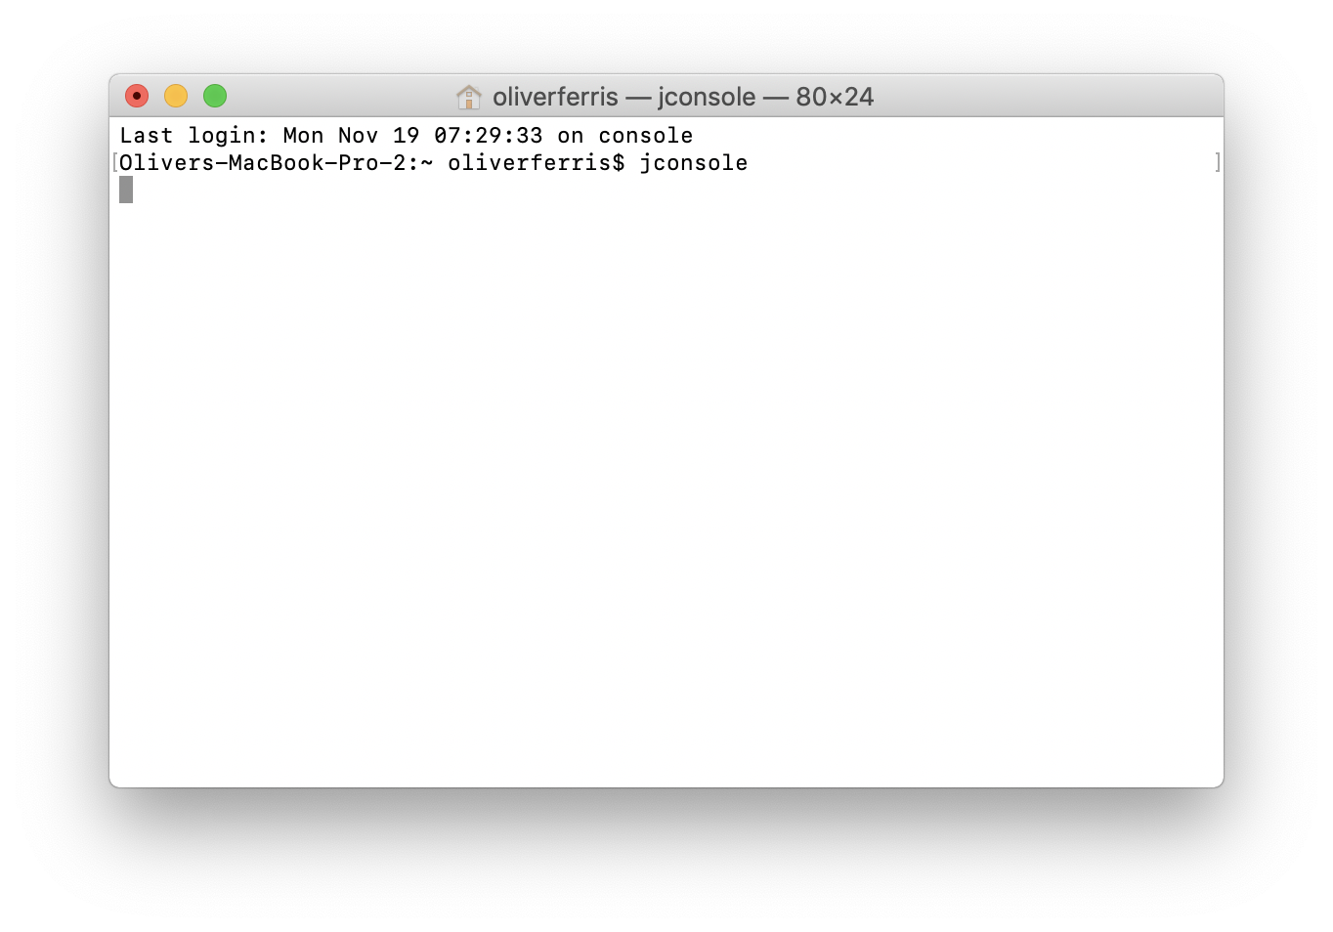Firstly I opened terminal and ran the command to open the GUI for jconsole

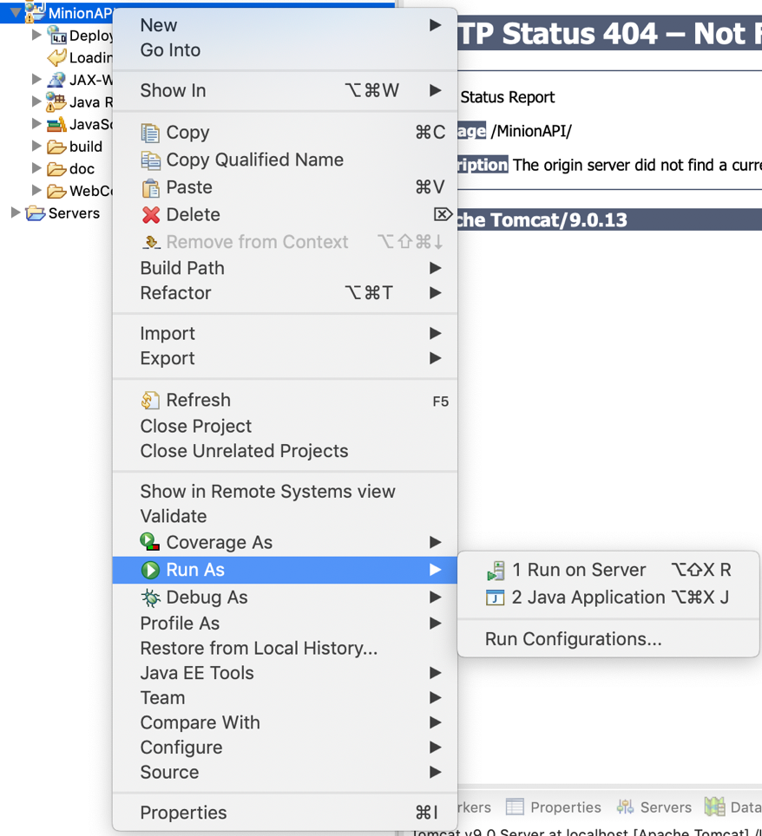Once jconsole was running I went into eclipse and ran the program I wanted to run my test on.

When the program successfully compiled and was running, I selected the now running program from the menu in jconsole

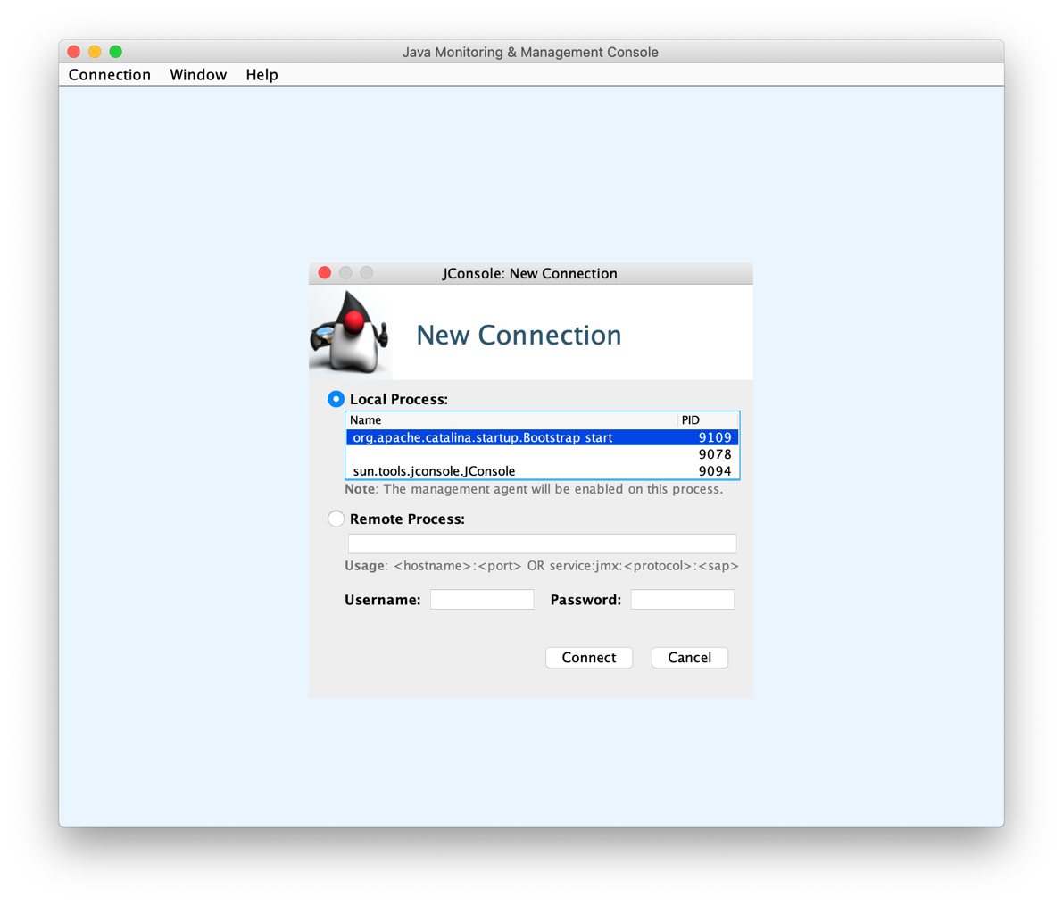

I was then presented with a number of graphs and charts displaying information about my program such as Memory and CPU usage, As well as the number of threads being used

